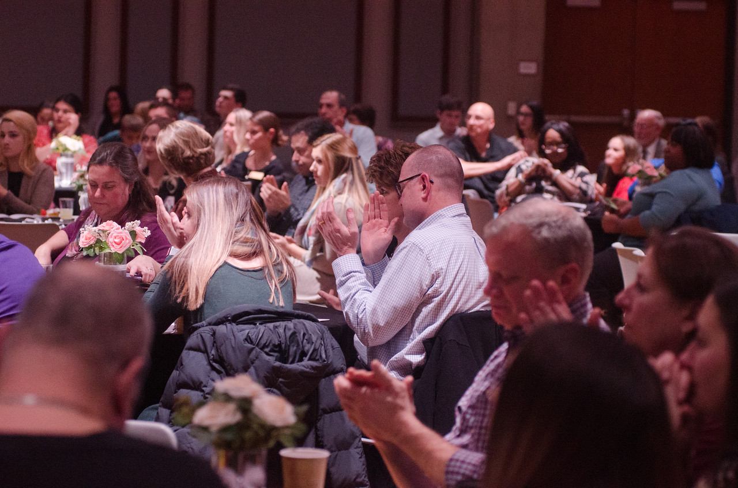

Event Application
For Buffalo State Faculty and Staff

Completion of this form is a request only, not a confirmed reservation.
All applications must be submitted at least 10 business days prior to the proposed event to the Buffalo State Events Management Office (eventmgt@buffalostate.edu). Incomplete applications will not be processed. Please note that academic classes and all college events will have scheduling priority.
This form must be completed for every event requested at Buffalo State. Thank you for working with us in our effort to maintain high and consistent standards for all events.
Today’s Date: Click or tap to enter a date.

Applicant Information

Event Contact | Click or tap here to enter text.
Sponsoring Department | Click or tap here to enter text.
Co-Sponsor | Click or tap here to enter text.
Contact Email Address | Click or tap here to enter text.
Contact Phone | Click or tap here to enter text.
Contact Campus Address | Click or tap here to enter text.

Event Information

Event Name | Click or tap here to enter text.
Event Date(s) | Click or tap here to enter text.
Time of Use (set-up through breakdown) | Click or tap here to enter text.
Event Start Time | Click or tap here to enter text.
Space Requested | Click or tap here to enter text.
Do you require break out rooms? | Choose an item.
Do you require lobby space? | Choose an item.
Target Audience (select all that apply) | ☐ BSC Students  ☐ BSC Faculty Staff  ☐ External to BSC  ☐ Invite Only
# Attending | Click or tap here to enter text.
Is there an admission charge? | Choose an item.
If yes, amount | Click or tap here to enter text.
Do you require parking? | Choose an item.
Do you require housing? | Choose an item.
Will you have external vendors? | Choose an item.
If yes, please provide vendor information | Click or tap here to enter text.
List any high-profile guests | Click or tap here to enter text.
Will there be food service? | Choose an item.
If yes, name of caterer | Click or tap here to enter text.
Type of food service (check all that apply) | ☐ Breakfast  ☐ Lunch  ☐ Dinner  ☐ Refreshments Only
Will alcohol be served? | Choose an item.
Technical Needs (check all that apply). | ☐Wi-Fi Access  ☐ Projection  ☐ Microphone  ☐ Lectern  ☐ RITE/Equipment Loan Support
Please detail any additional technical needs. | Click or tap here to enter text.
Please detail any equipment needs (tables, chairs, easels, etc.), | Click or tap here to enter text.
Please provide a brief description of the event. | Click or tap here to enter text.

Please return the completed event application to eventmgt@buffalostate.edu

Once we receive the completed form, our office will contact you to discuss your request.

